ECS and ECR

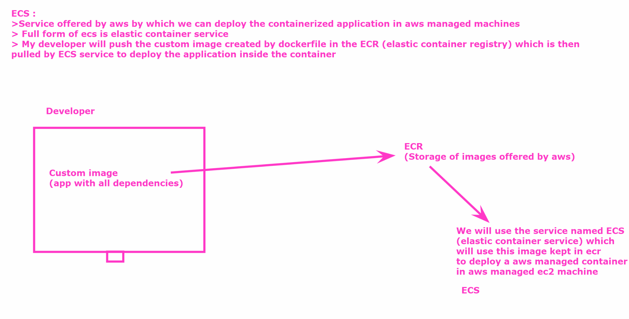

PROJECT : https://github.com/akshu20791/ECS-AWS-LAB

Go in your docker ec2 ubuntu machine

# sudo su

git clone <https://github.com/akshu20791/ECS-AWS-LAB>

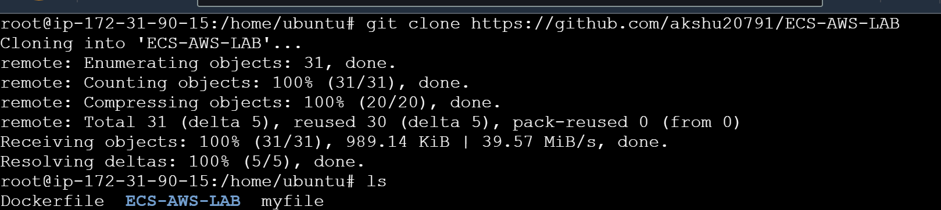

# cd ECS-AWS-LAB (to enter inside the repo which we created)

# ls



In above all the project file is present

WE WILL NOW CREATE ECR (ELASTIC CONTAINER REGISTRY)

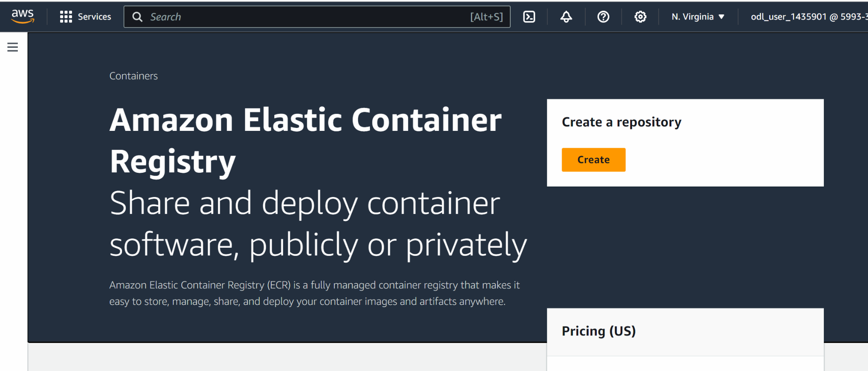

Create

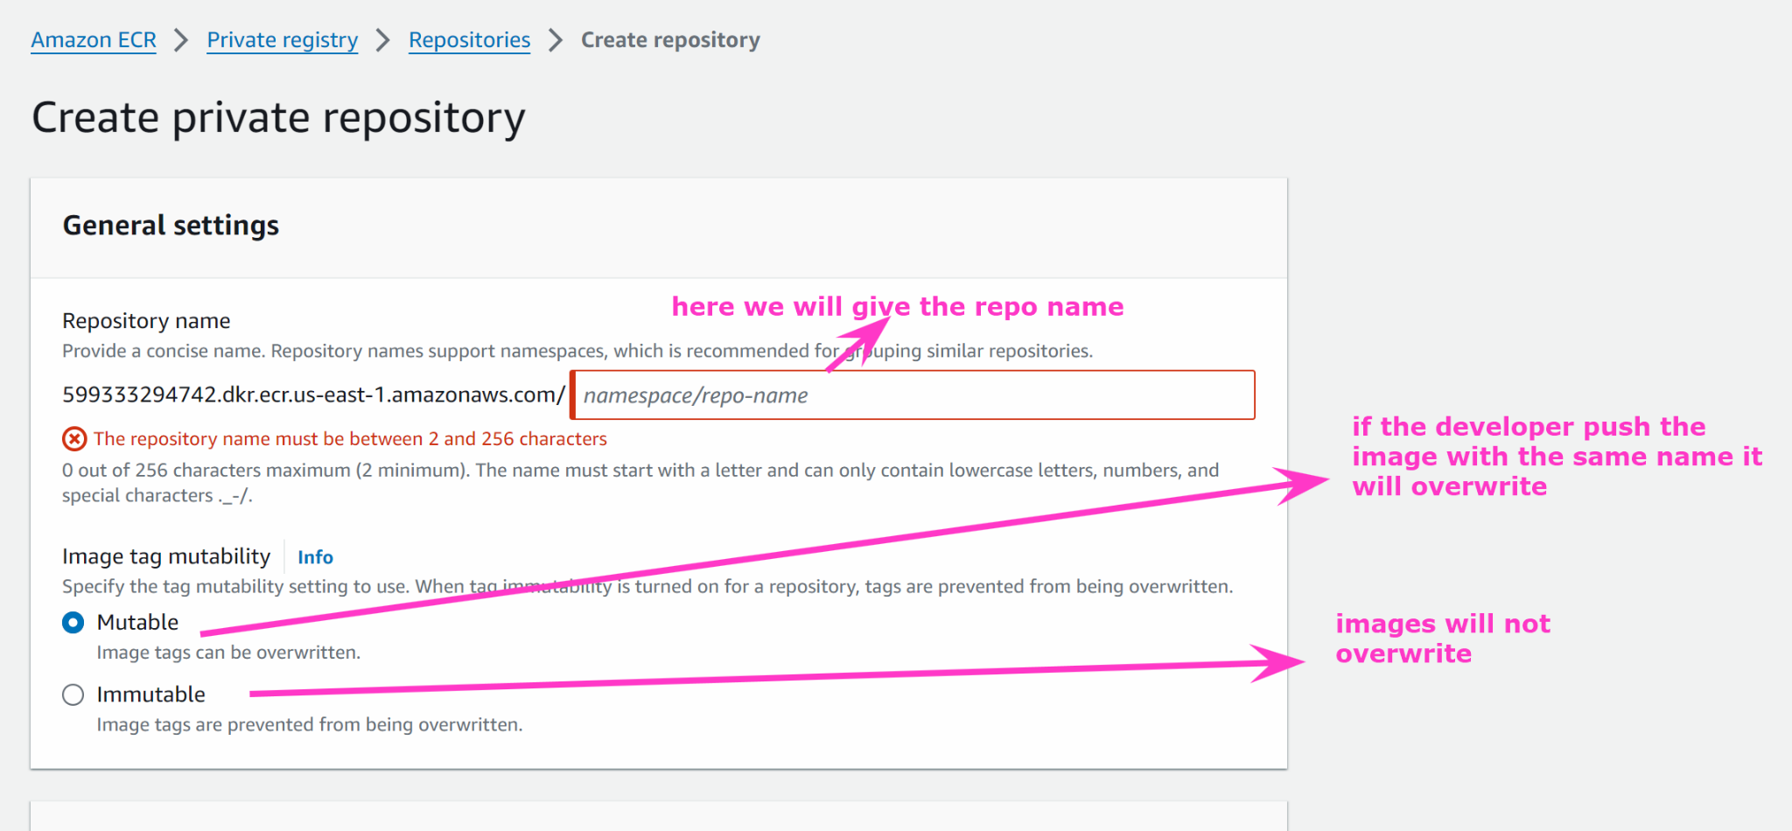

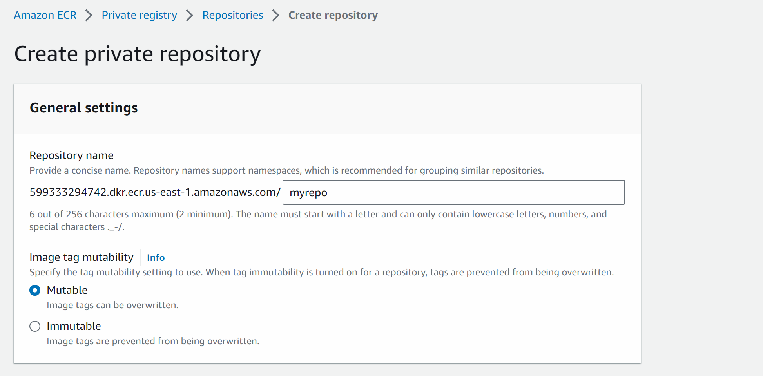

Create

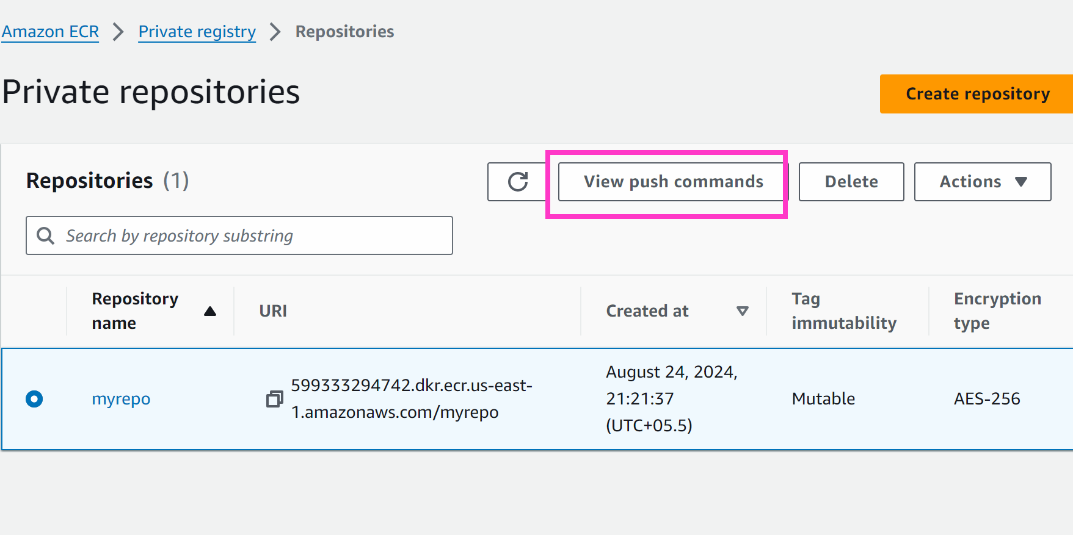

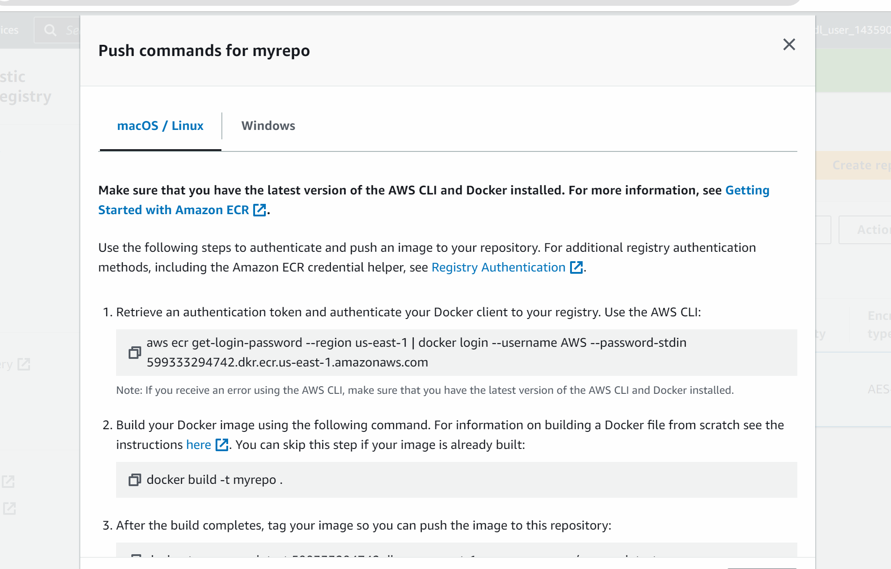

But before entering these commands in the machine we need to use secret key and access secret key to get access of aws account from the machine

To generate access key and secret access key 👍

Go to iam -> go to user which is already created for you

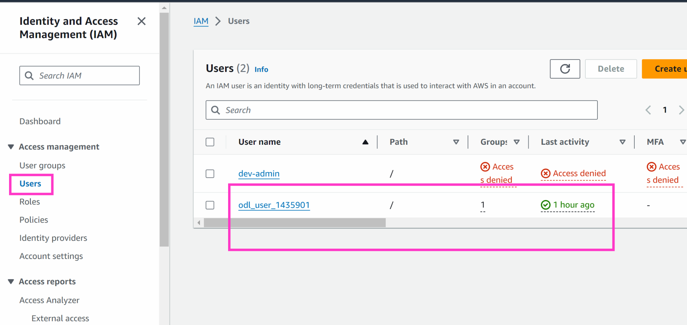

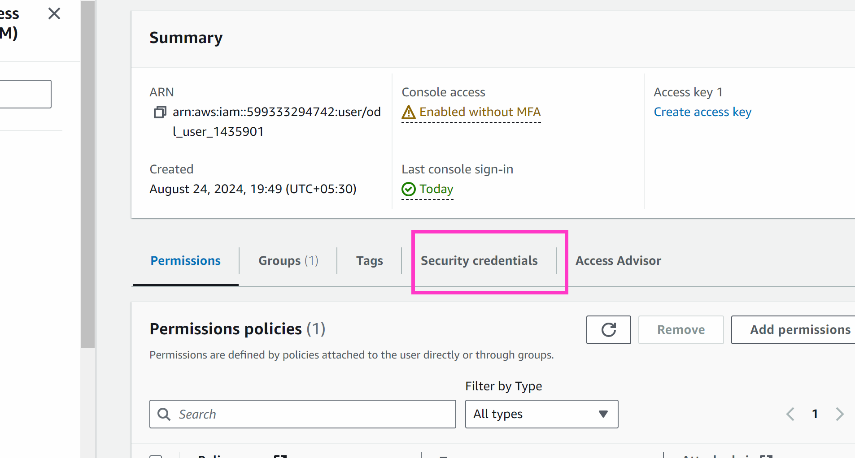

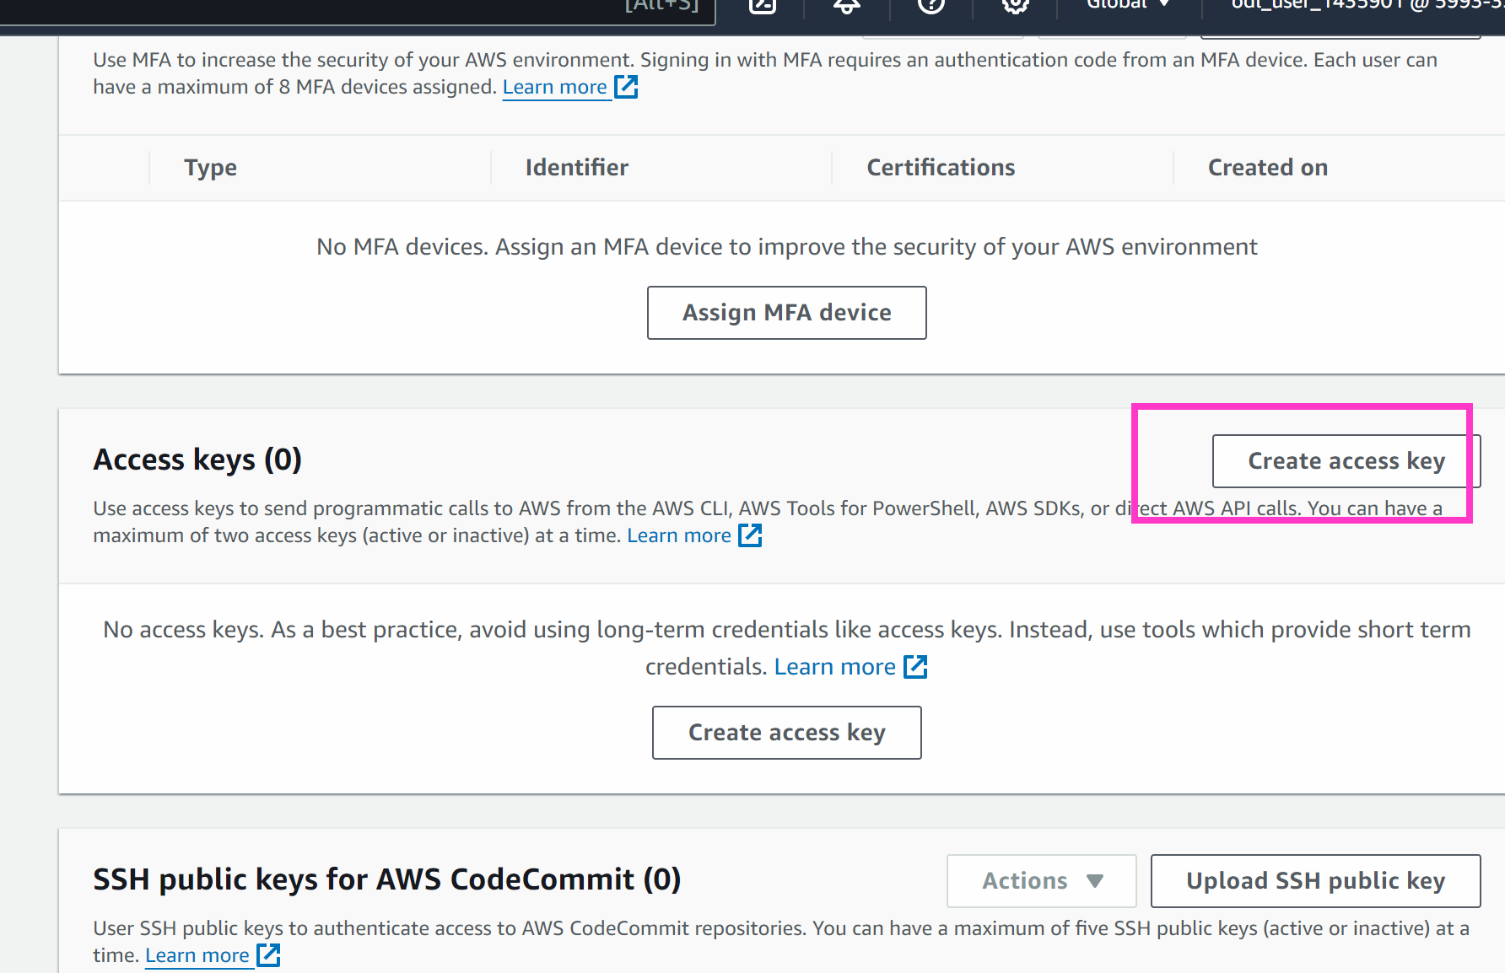

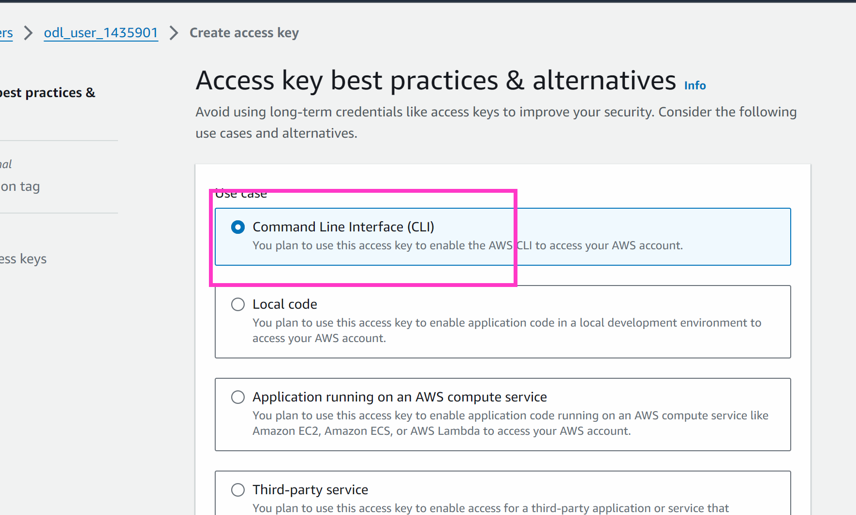

Next

Create access keys

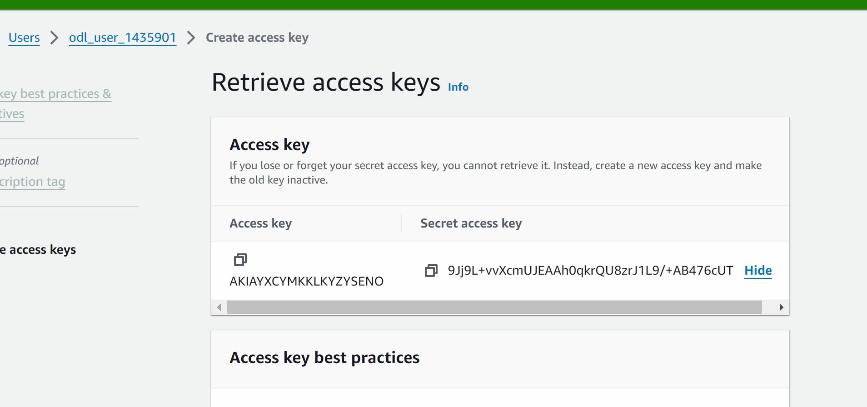

Now copy the access key

Go to your ec2 machine

curl "https://awscli.amazonaws.com/awscli-exe-linux-x86_64.zip" -o "awscliv2.zip"

apt install unzip -y

unzip awscliv2.zip

sudo ./aws/install

aws configure

# it will ask for accesskey and secret access key which we can copy

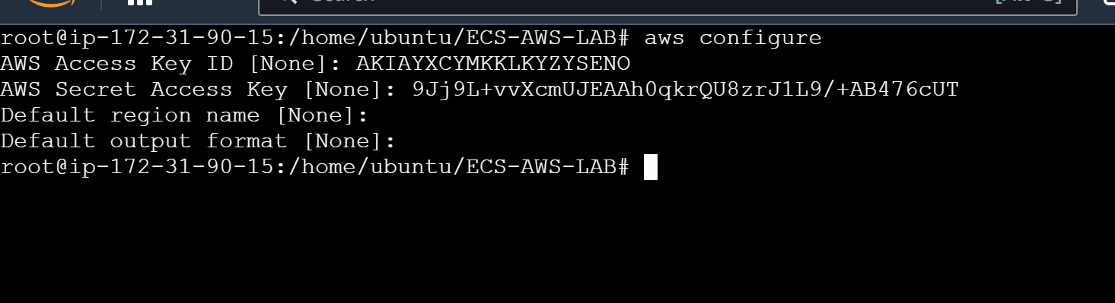

Installing docker

# apt update

# apt install docker.io -y

Now we will go to ECR

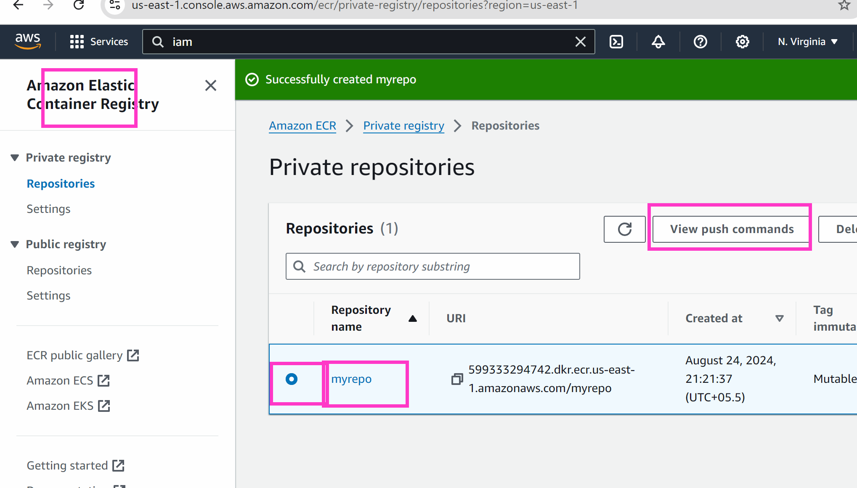

Copy the below commands one by one in your machine

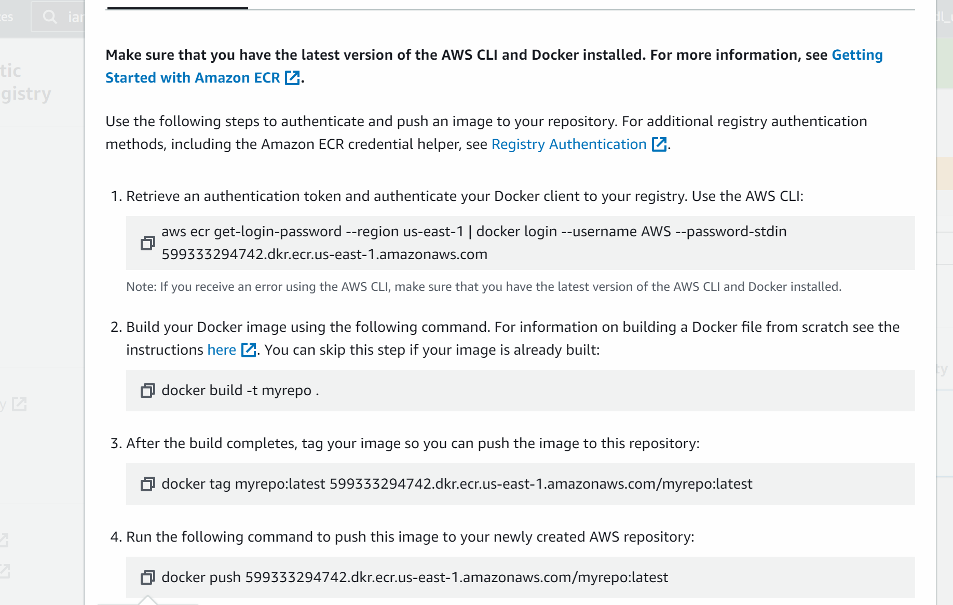

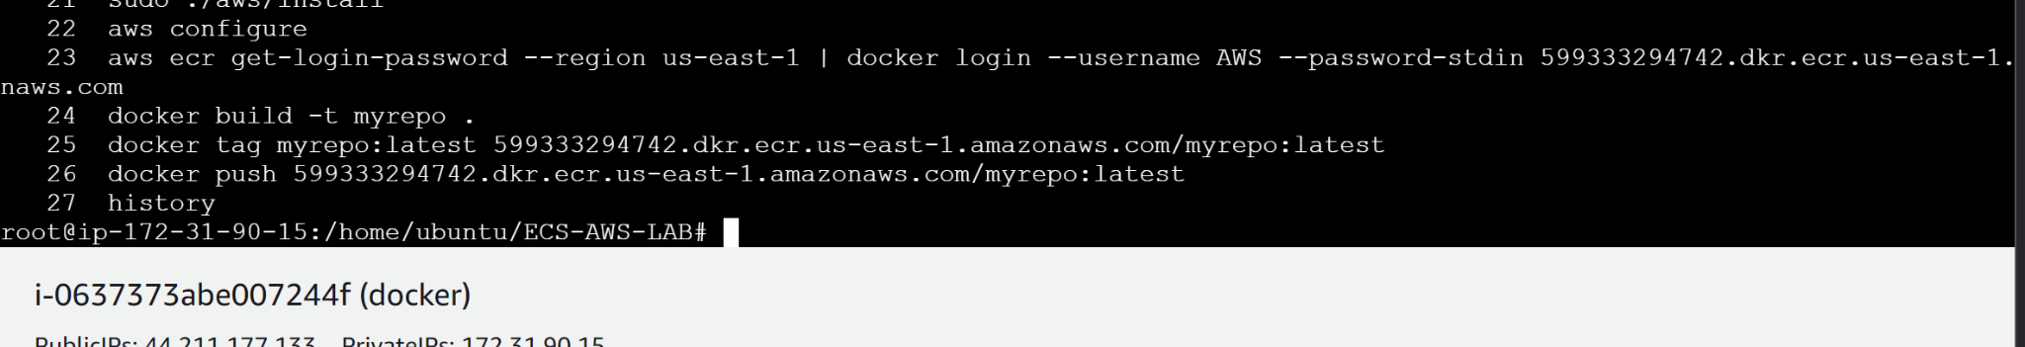

###############

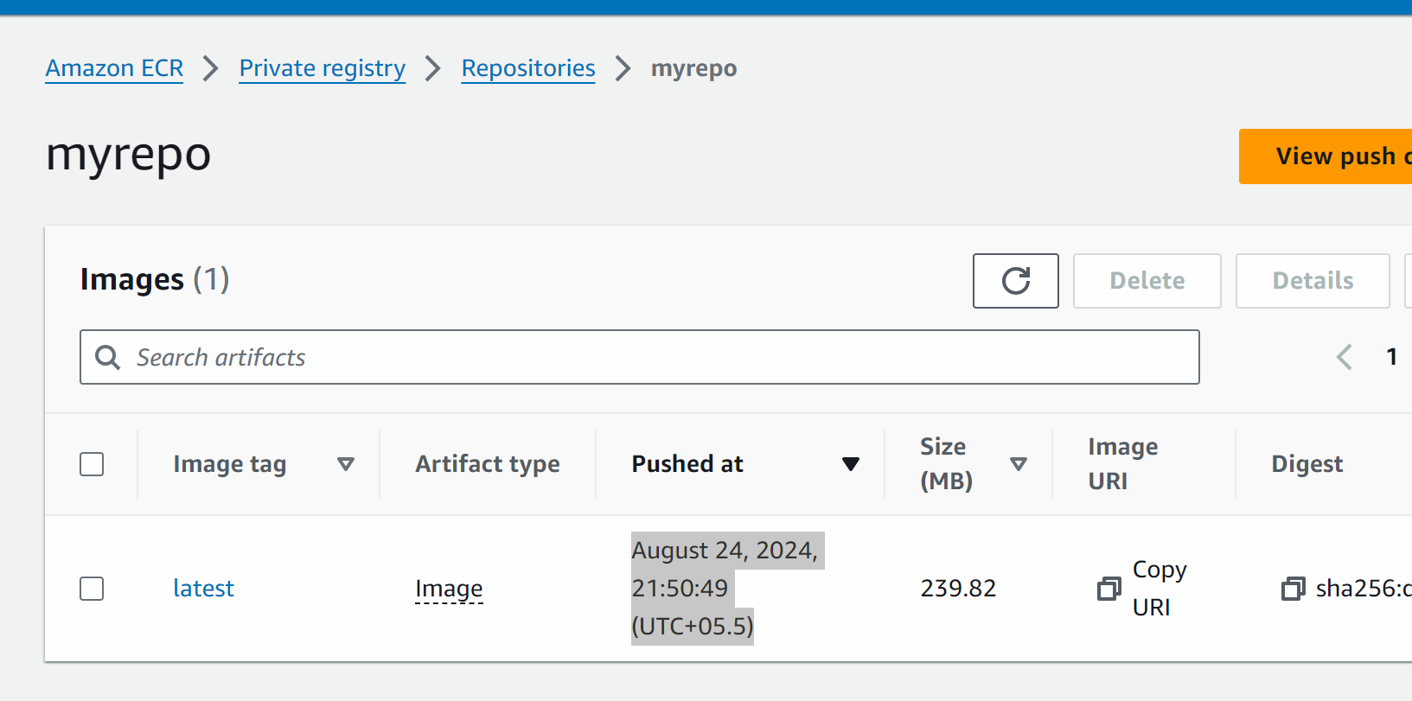

We have pushed the image on ecr which should be used by ecs to create a continainer with custom image

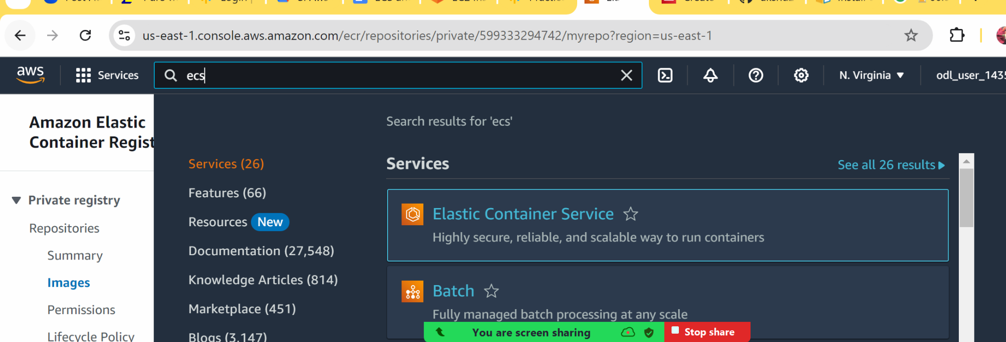

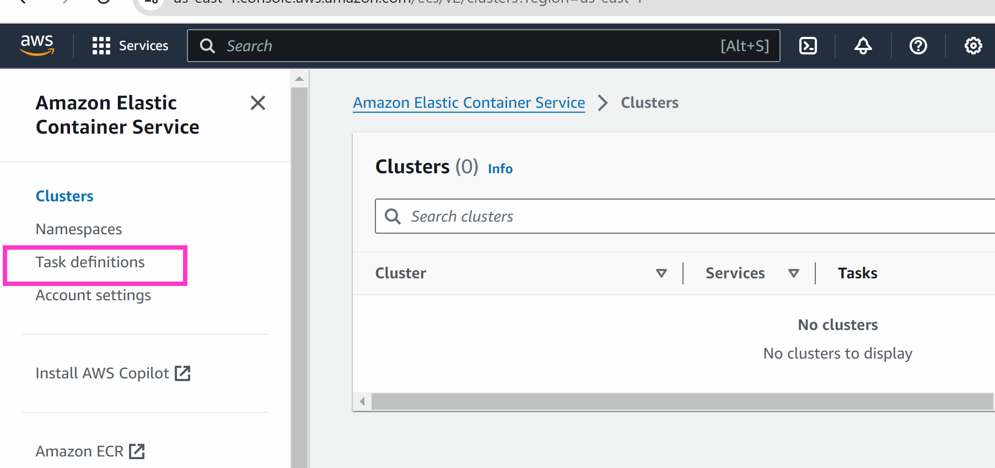

Create a new task definition

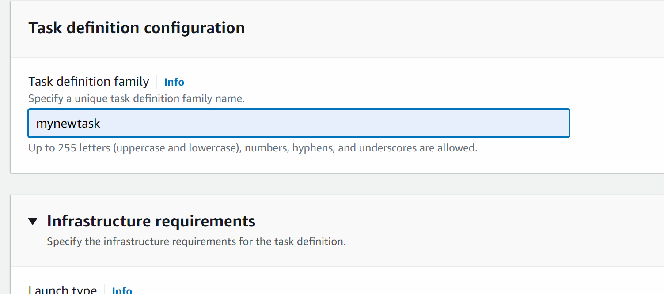

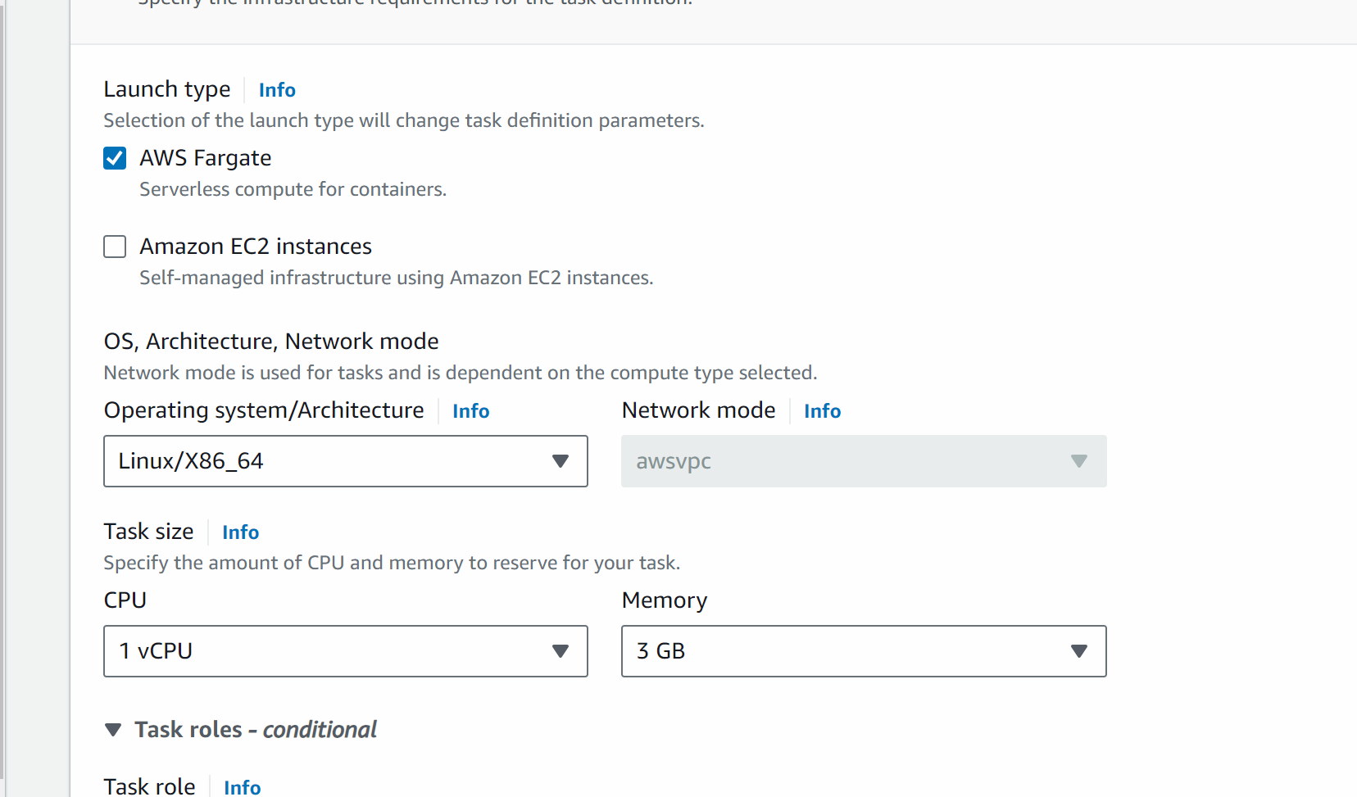

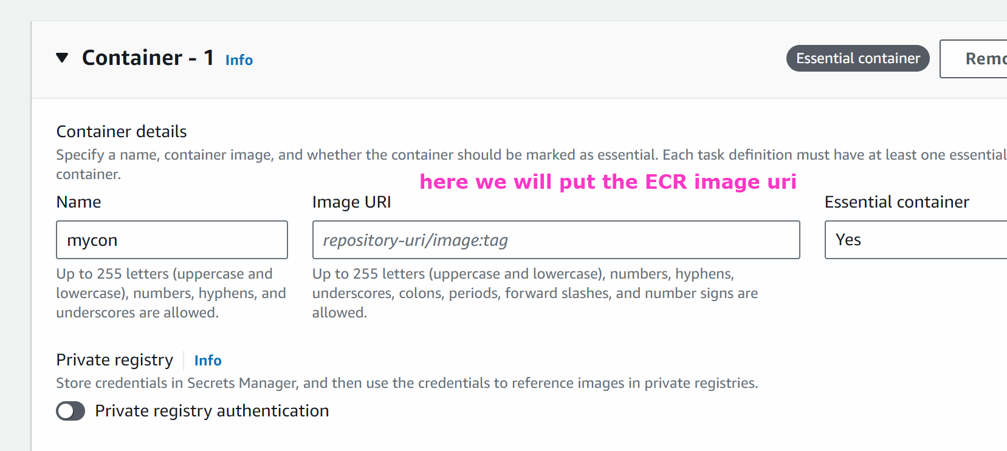

Open ecr in new tab and copy the image

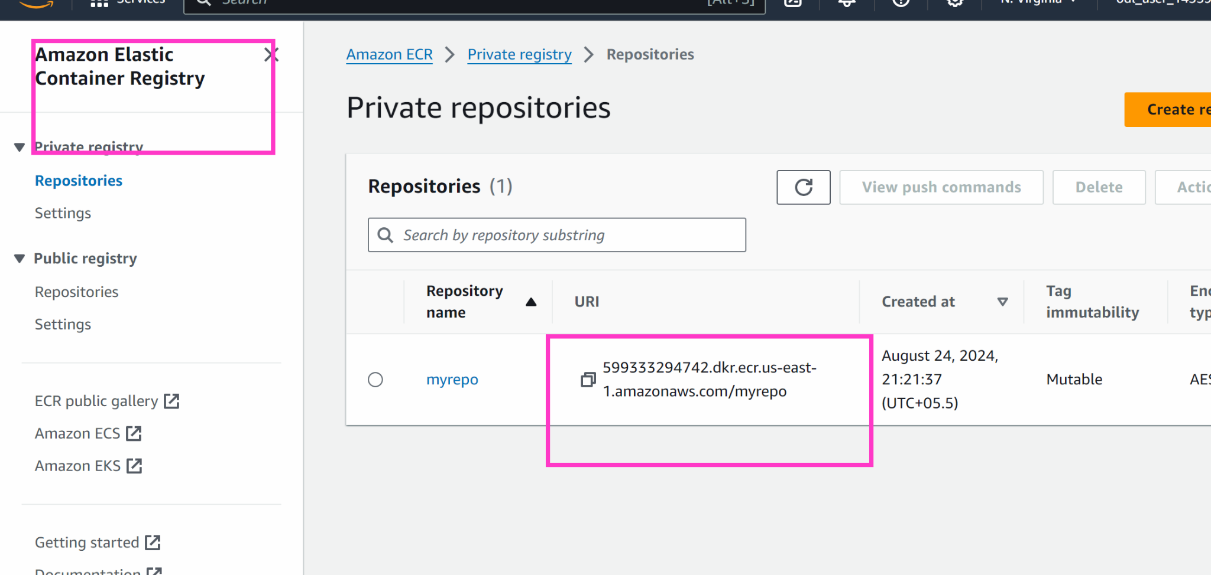

Go back to ecs task definition

And paste the image uri

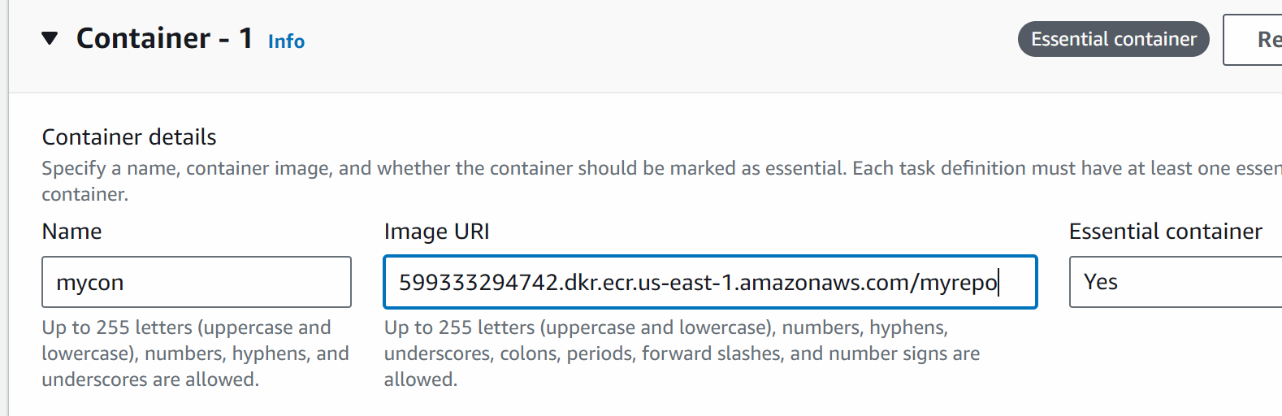

Scroll down and create task definition

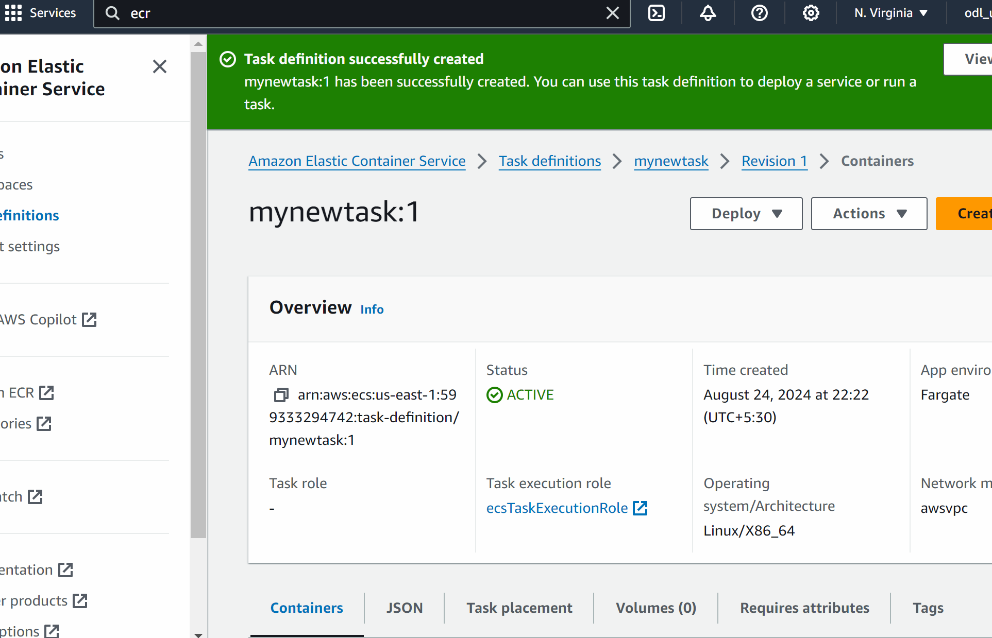

#### Now we will do and create the ECS cluster

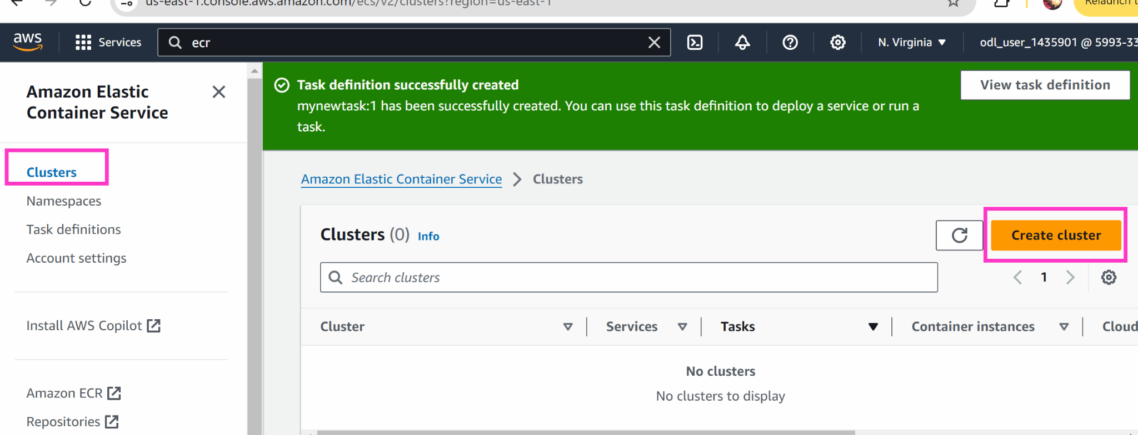

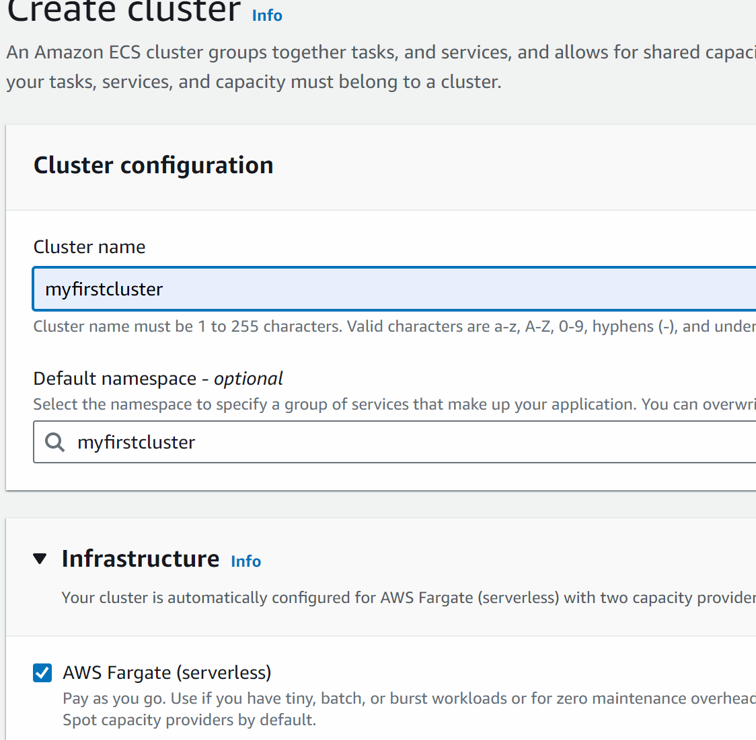

Create

# if error comes up create cluster again with different name

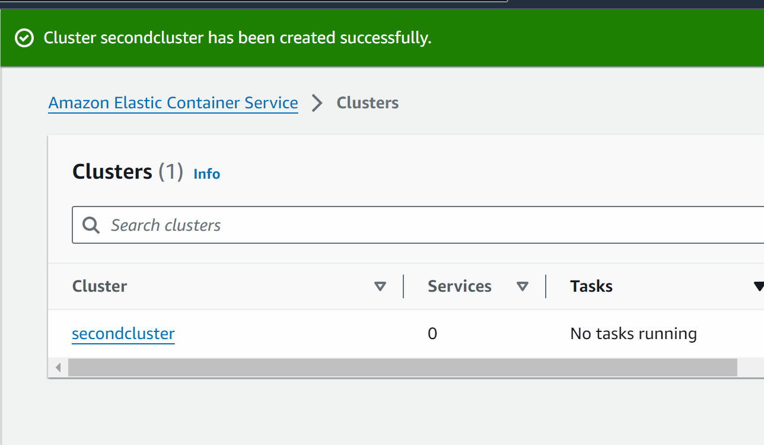

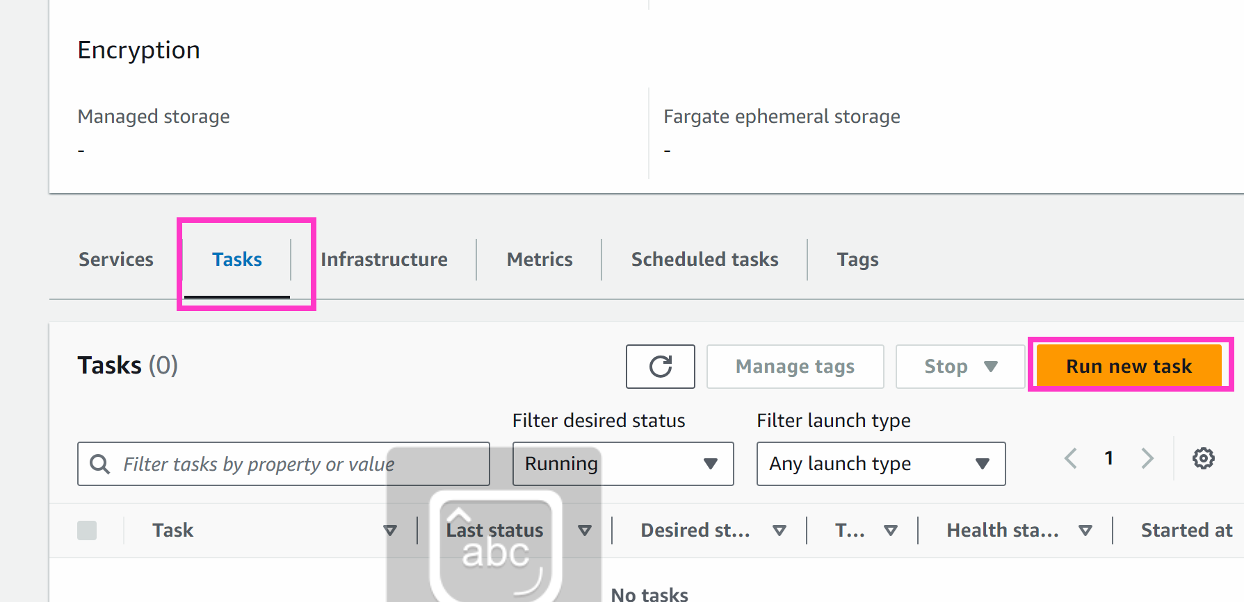

Task : inside infra we want to deploy the container

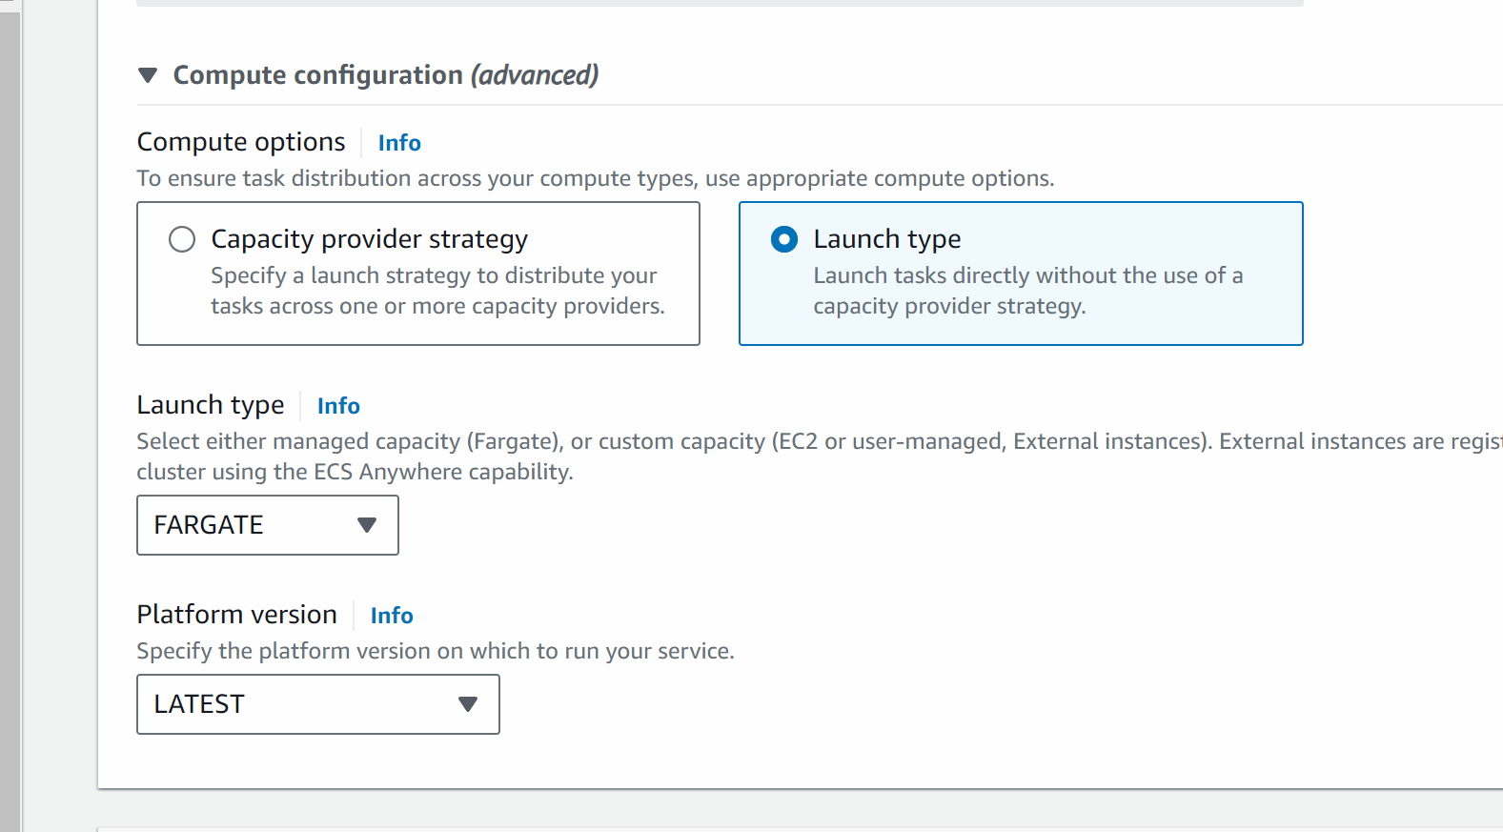

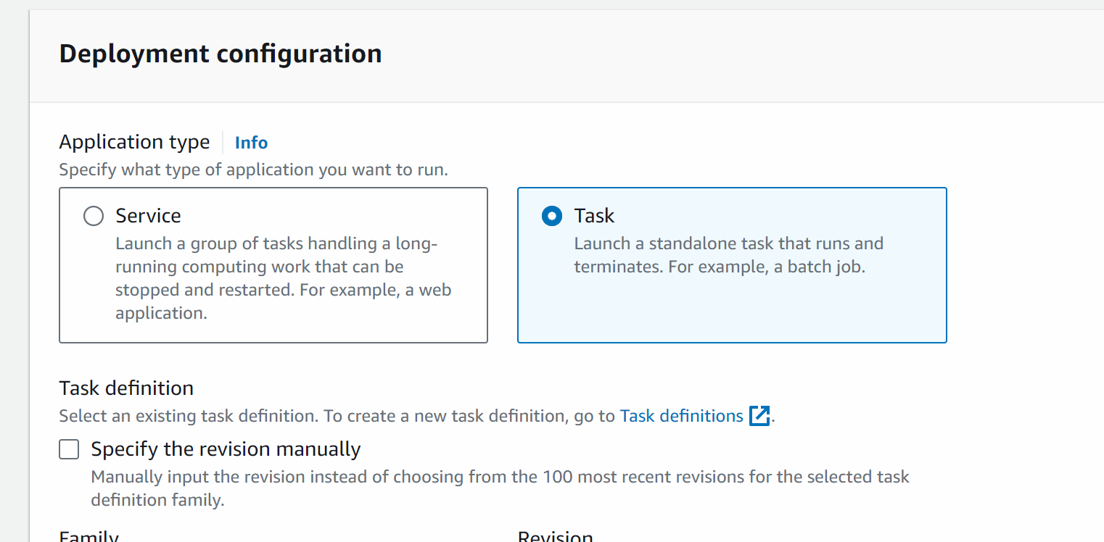

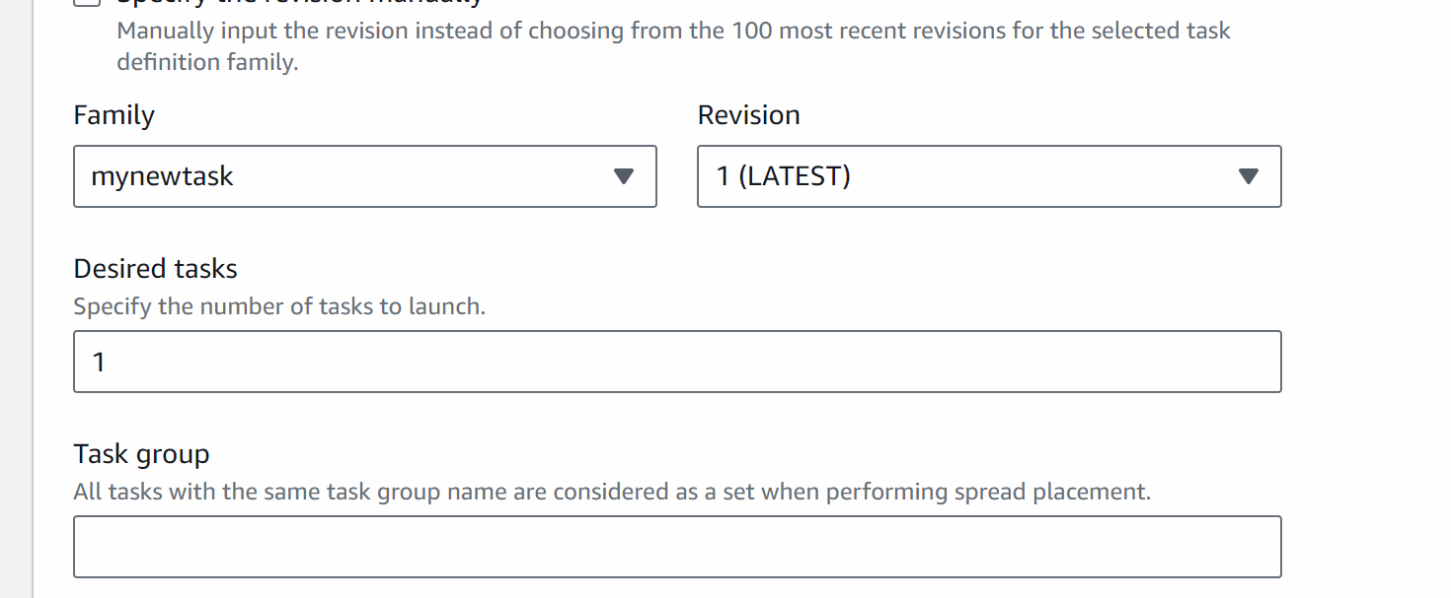

Click on networking

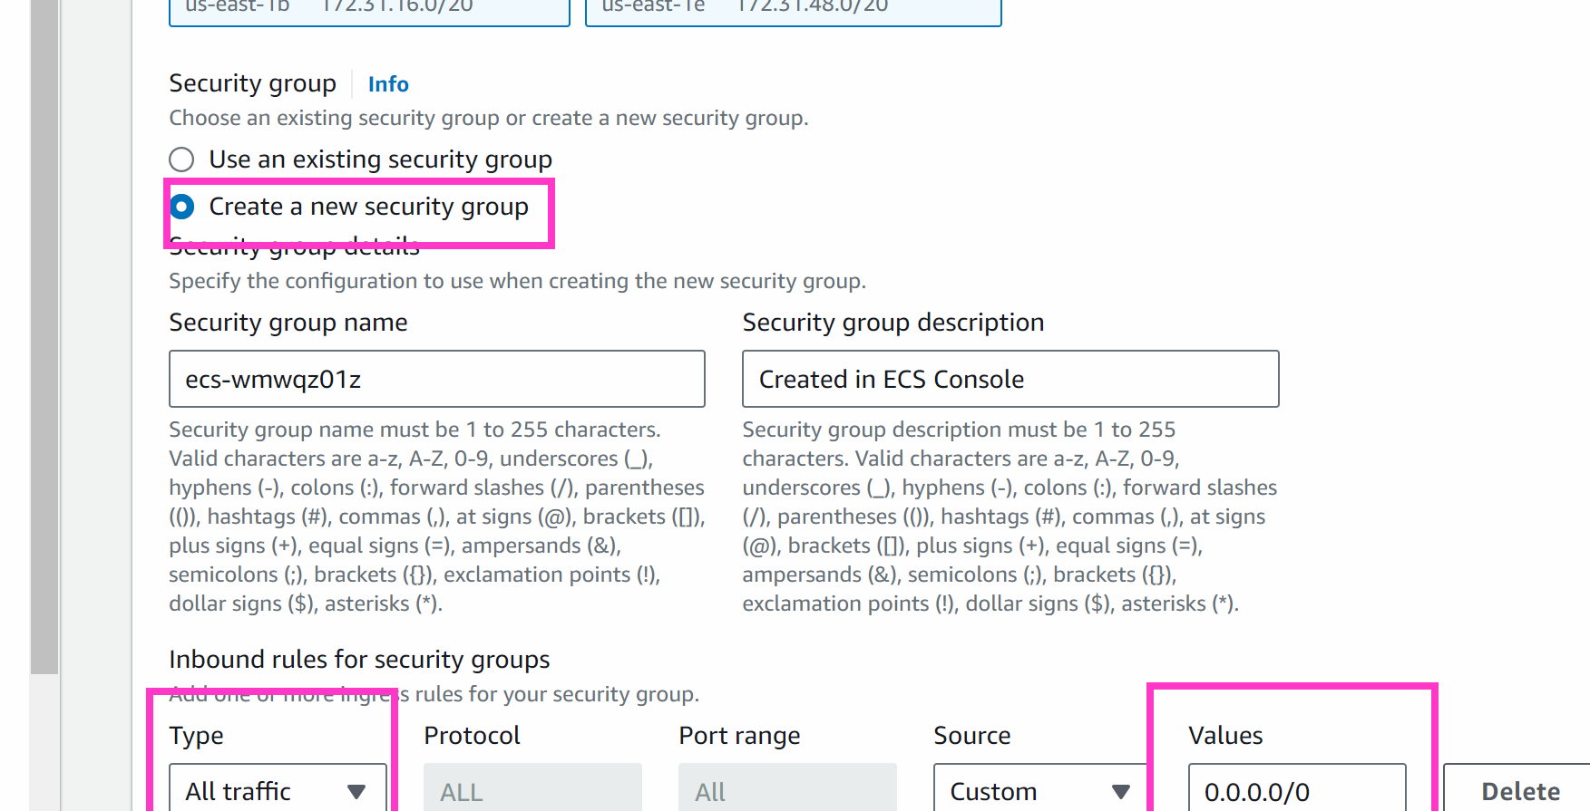

Create

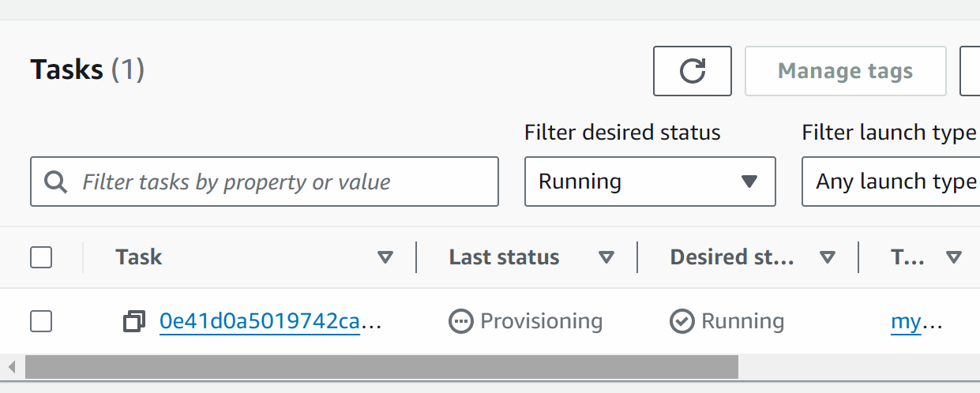

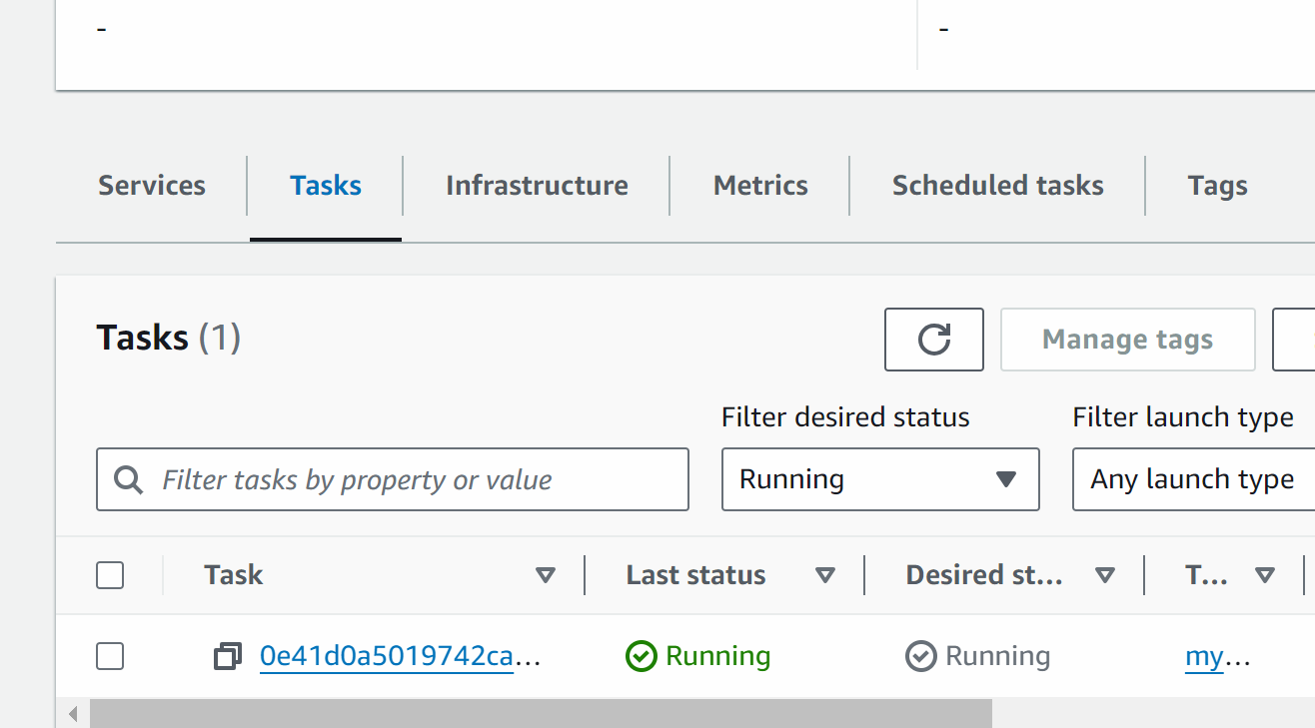

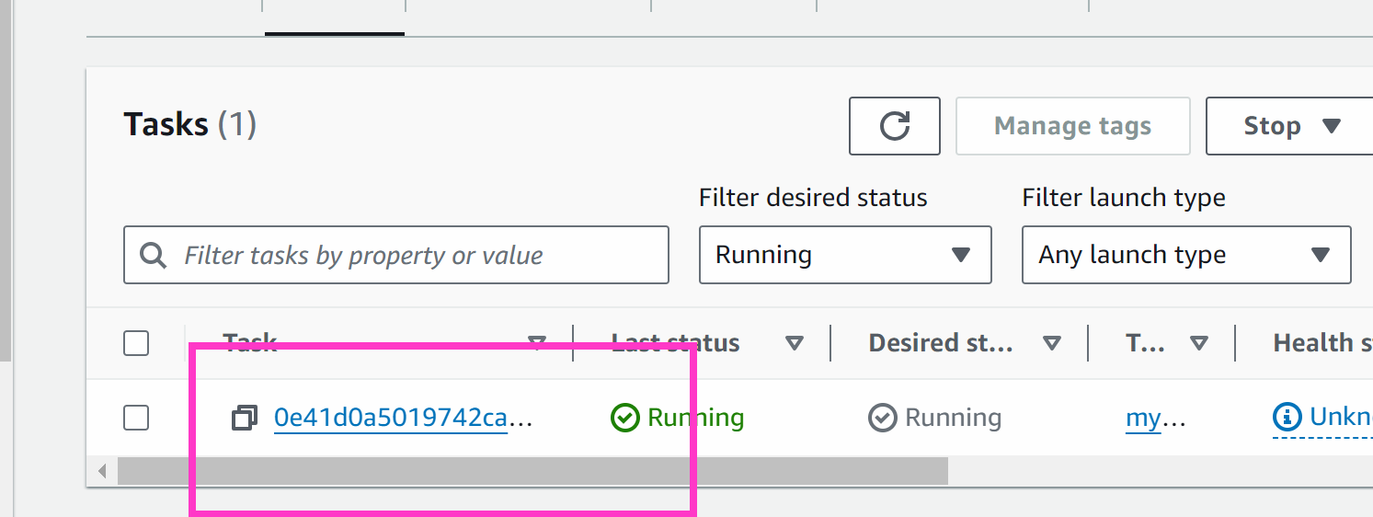

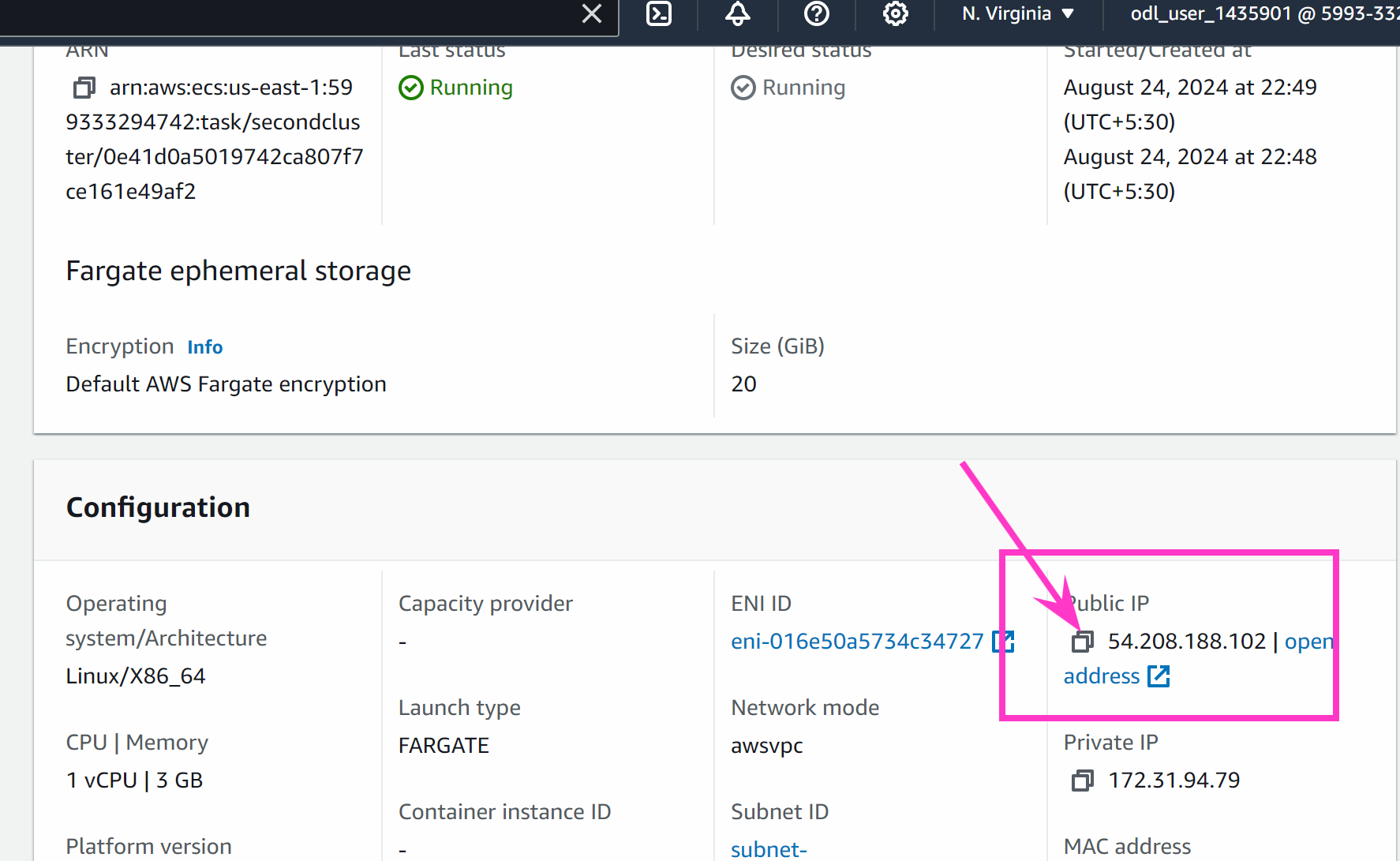

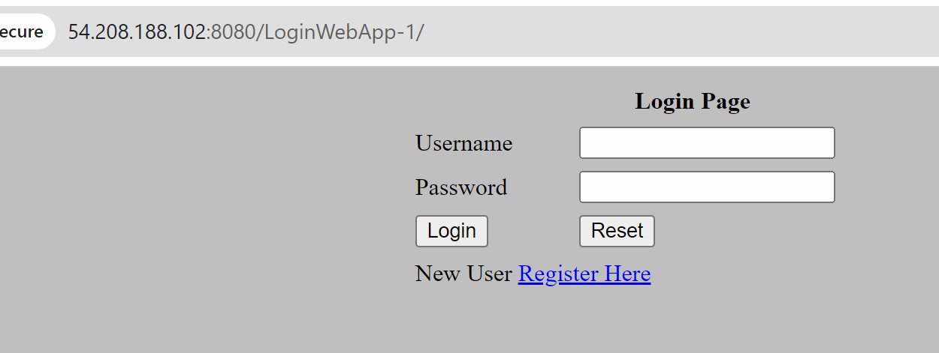

<http://54.208.188.102:8080/LoginWebApp-1/>